Project Report on
THE SMART AGRICULTURE LINE FOLLOWING BOT

Submission to THE ROBOTICS CLUB - SNIST as a part of INDUCTION'24
TEAM NO - 05

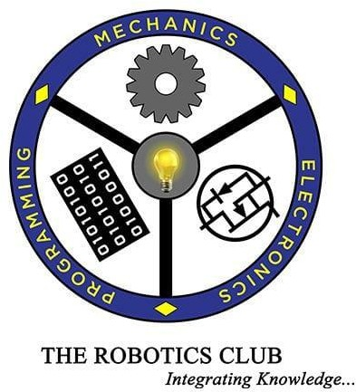

THE ROBOTICS CLUB-SNIST

SREENIDHI INSTITUTE OF SCIENCE AND TECHNOLOGY
(AUTONOMOUS)
(Affiliated to JNTU University, Hyderabad) Yamnampet, Ghatkesar, Hyderabad – 501301.

2024

CERTIFICATE

This is the project work titled ‘THE SMART AGRICULTURE LINE FOLLOWING BOT by ‘ Ashish, Eesha, Hemanth, Shruthi, Ramya, Abrar, Umair, Charan, Varshitha, Akshaya ’ under the mentorship of ‘Rohit andBhavishya’ and is a record of the project work carried out by them during the year 2023-2024 as part of INDUCTION under the guidance and supervision of

Mr. G. Kovidh Addhish
&
Mr. Aarushraj Puduchery

Joint secretary for technical affairs

Mr. N V V S Narayana The President of
THE ROBOTICS CLUB
Dr. A. PURUSHOTHAM
Faculty Advisor
Mechanical Department

DECLARATION

The project work reported in the present thesis titled “THE SMART AGRICULTURE LINE FOLLOWING BOT” is a record work done by Team 05 in THE ROBOTICS CLUB as a part of INDUCTION-2024.

No part of the thesis is copied from books/ journals/ Internet and wherever the portion is taken, the same has been duly referred in the text. The report is based on the project work done entirely by TEAM 05 and not copied from any other source.
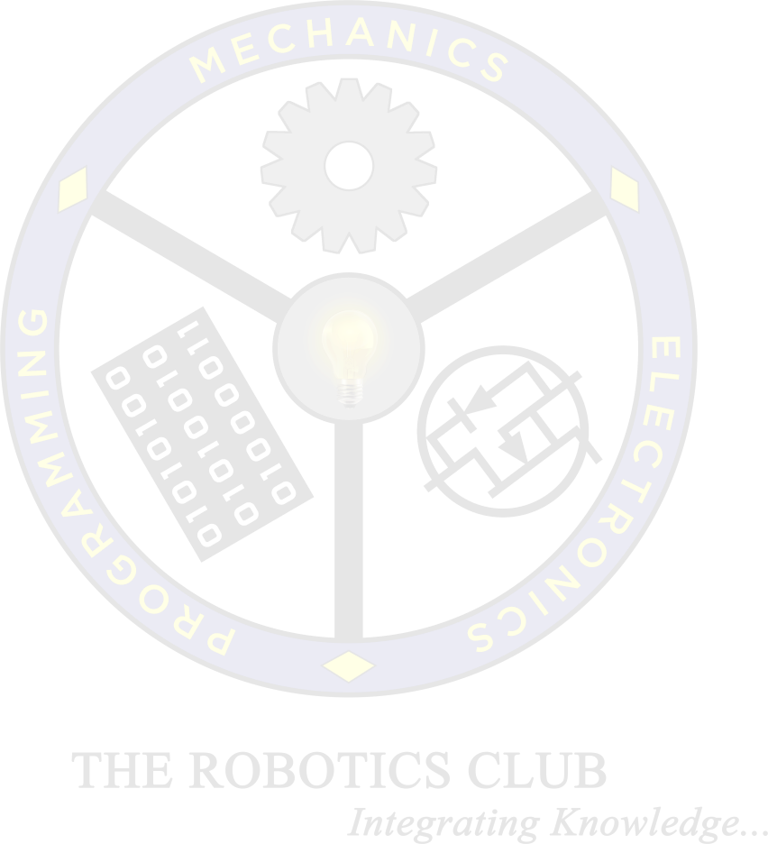

ACKNOWLEDGMENT

This project report is the outcome of the efforts of many people who have driven our passion to explore into implementation of the SMART AGRICULTURE LINE FOLLOWING BOT. We have received great guidance, encouragement and support from them and have learned a lot because of their willingness to share their knowledge and experience.

Primarily, we would like to express our gratitude to our mentors, Rohit and Bhavishya. Their guidance has been of immense help in surmounting various hurdles along the of our goal.

We thank our joint secretary of technical affairs ”Mr.G.Kovidh Addhish & Mr.Aarushraj Puducherry”for being with us till the end of project complition.

We thank all the members of Steering Body, Executive Body, Technical Advisory Board, Club’s Incubation and Competence Committee of The Robotics Club for helping us with crucial parts of the project. We are deeply indebted to Mr. N V V S Narayana – The President, Ms. Mugala Shravani- The Vice President and Ms. Maliha – SAB Chairman and Mr. N Abhinav – General Secretary THE ROBOTICS CLUB respectively and also every other person who spared their valuable time without any hesitation whenever we wanted.

We also thank our faculty advisor Dr. A. PURUSHOTHAM, Professor, Mechanical Department, who encouraged us during this project by rendering his help when needed.

List Of Contents

Chapter 1 | Introduction: |  |  | PageNo.
1.1 | Problem Statement |  |  | 6
1.2 | Introduction of the project |  |  | 7
1.3 | Existing System |  |  | 7
1.4 | Proposed System |  |  | 8
Chapter 2 | Architecture
2.1 | Hardware |  |  | 8-10
2.2 | Software |  |  | 11-12
Chapter 3 | Implementation and Working
3.1 | Circuit Digram |  |  | 12
3.2 | Block Digram |  |  | 12
3.3 | Working Mechanism |  |  | 12
Chapter 4 | Experimental Results and Conclusions:
4.1 | Results |  |  | 12
4.2 | Future Enhancements |  |  | 12
4.3 | Conclusion |  |  | 12
4.4 | References |  |  | 13
4.5 | Source Code |  |  | 13-14
4.6 | Expenses List |  |  | 14

ABSTRACT

INDUCTION’24

TEAM-05
THE SMART AGRICULTURE LINE FOLLOWING BOT

THE PROBLEM:

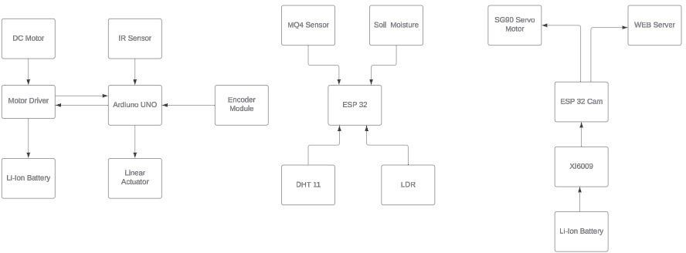Agricultural fields are vulnerable to various environmental factors and threats such as soil humidity fluctuations, pollution levels, and weather conditions, which can significantly impact crop yield and quality. Additionally, monitoring these fields manually can be time-consuming, costly, and inefficient, leading to delayed detection of issues and suboptimal decision- making for farmers.

TEAM’S APPROACH TO SOLVE THE PROBLEM:

Our project aims to address these challenges by developing an autonomous surveillance bot equipped with advanced sensors and technology. The bot will utilize a grid-based approach to systematically monitor agricultural fields, capturing real-time data on soil humidity levels, pollution concentrations, and weather conditions. Additionally, the bot will feature a 360-degree camera system for comprehensive field surveillance, enabling farmers to remotely monitor their crops and detect potential threats or anomalies promptly. By providing timely and accurate information, our surveillance bot will empower farmers to make data-driven decisions, optimize resource allocation, and enhance overall agricultural productivity and sustainability.

The Smart Agriculture Line Following Bot
M.Eesha, S. Ashish, P.Hemanth, A.Ramya, Shruthi,Charan, Abrar, Akshaya, Umair
June 22, 2024

Abstract
Agricultural fields are vulnerable to various environmen- tal factors and threats such as soil humidity fluctuations, pollution levels, and weather conditions, which can signif- icantly impact crop yield and quality. Additionally, moni- toring these fields manually can be time-consuming, costly, and inefficient, leading to delayed detection of issues and suboptimal decision-making for farmers. Our project aims to address these challenges by developing an autonomous surveillance bot equipped with advanced sensors and tech- nology. The bot will utilize a grid-based approach to sys- tematically monitor agricultural fields, capturing real-time data on soil humidity levels, pollution concentrations, and weather conditions. Additionally, the bot will feature a 360- degree camera system for comprehensive field surveillance, enabling farmers to remotely monitor their crops and de- tect potential threats or anomalies promptly. By providing timely and accurate information, our surveillance bot will empower farmers to make data-driven decisions, optimize resource allocation, and enhance overall agricultural pro- ductivity and sustainable.

Introduction
Our bot is a Smart agriculture is rapidly transforming tra- ditional farming practices through the integration of ad- vanced technologies, enhancing productivity, and ensuring sustainability. One innovative application within this do- main is the development of smart agriculture line-following bots. These autonomous robots are designed to navigate agricultural fields with precision, following pre-determined lines or paths, and performing various tasks such as plant- ing, weeding, fertilizing, and monitoring crop health. The line-following bot leverages sensors, machine learning algo- rithms, and GPS technology to accurately track and main- tain its course along the designated lines. This automation reduces the need for manual labor, minimizes human er- ror, and increases efficiency in field operations. By consis- tently performing tasks with high accuracy, these bots help farmers optimize resource use, reduce costs, and enhance crop yields. Incorporating a line-following bot into agri- cultural practices not only streamlines operations but also ports sustainable farming by enabling precise application of inputs, reducing wastage, and promoting environmentally friendly practices. As the agriculture sector continues to
evolve, smart technologies like these bots play a crucial role in meeting the growing global demand for food while pre- serving the ecosystem.

1.1 Existing System
A smart agriculture line-following bot is an autonomous robot designed to perform various agricultural tasks by fol- lowing pre-defined paths or lines in the field. These robots are integrated with smart technologies to enhance efficiency and precision in farming operations. Below, I’ll provide an overview of the existing systems and their components.

1.2 Proposed System
A smart agriculture line-following bot is designed to au- tonomously navigate through agricultural fields, perform- ing tasks such as planting, watering, fertilizing, and mon- itoring crops. Here’s a proposed system for such a bot.LineFollowing Mechanism* Sensors: Infrared (IR) or optical sensors to detect lines on the ground. Microcon- troller: Processes sensor data and adjusts the bot’s path to follow the line. - The bot starts at a designated point in the field. - It follows pre-laid lines (could be white tape or painted lines) using its IR sensors. - While moving, it continuously monitors soil moisture and environmental con- ditions. - When soil moisture drops below a certain thresh- old, it activates its watering system to irrigate the crops.
- It logs all data, which is sent to the cloud for real-time monitoring and historical analysis. - If an obstacle is de- tected, it navigates around it and continues its path. This system can be further enhanced with machine learning algo- rithms to optimize task execution based on historical data and pattern.

Architecture

ESP32-Cam
The ESP32-CAM is a versatile development board that combines the ESP32 microcontroller with a camera mod- ule.It comes with an OV2640 camera and provides onboard TF card slot. The ESP32-CAM is widely used for projects involving video streaming, image capture, and home secu- rity applications, making it a valuable tool in the realm of embedded systems and the Internet of Things (IoT).

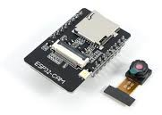

Figure 1: ESP32-Cam

Li-ion batteries
A lithium-ion or Li-ion battery is a type of rechargeable battery which uses the reversible reduction of lithium ions to store energy. The anode (negative electrode) of a conven- tional lithium-ion cell is typically graphite made from car- bon. The cathode (positive electrode) is typically a metal oxide. The electrolyte is typically a lithium salt in an or- ganic solvent.
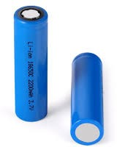

Figure 2: Li-Ion Battery

Buck Booster XL 6009
DC-DC Step Up Down Boost Buck Voltage Power Converter Module is a non-isolated Step up and step down ( boost as well as buck) constant voltage (CV) DC-DC converter Module.Maximum Output Current 4a XL6009 DCDC Step-Up Boost Converter, 5 To 35v Dc (adjustable),
- To 32v Dc.XL6009 Module is A non-isolated step-up (boost) voltage converter featuring adjustable output volt- age and high efficiency.

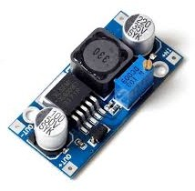

Figure 3: Buck Booster XL 6009

Bread board
An electronics breadboard (as opposed to the type on which sandwiches are made) is actually referring to a solder-less breadboard. These are great units for making temporary circuits and prototyping, and they require absolutely no soldering.The foundation to construct and prototype elec- tronics. A breadboard allows for easy and quick creation of temporary electronic circuits or to carry out experiments with circuit design.
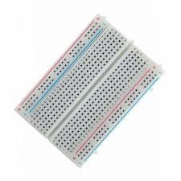

Figure 4: Bread Board

DTH 11
The DHT11 is a commonly used Temperature and humidity sensor that comes with a dedicated NTC to measure temperature and an 8-bit microcontroller to output the values of temperature and humidity as serial data.Wide Operating Range: The DHT11 can measure temperature in the range of 0°C to 50°C (32°F to 122°F) with an accuracy of ±2°C. For humidity, it can measure in the range of 20.

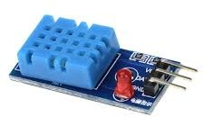

Figure 5: DTH 11

LDR
Light Dependent Resistor light sensor modules are used where there is a need to sense the presence and absence of light is necessary. These resistors are used as light sensors and the applications of LDR mainly include alarm clocks, street lights, light intensity meters, and burglar alarm circuits.LDR (light-dependent resistors) are used to detect light levels, eg in automatic security lights. Their resistance decreases as the light intensity increases.

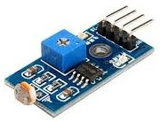

Figure 6: LDR

Soil Moisture Sensor
The Soil Moisture Sensor uses capacitance to measure dielectric permittivity of the surrounding medium. In soil, dielectric permittivity is a function of the water content. The sensor creates a voltage proportional to the dielectric permittivity, and therefore the water content of the soil.

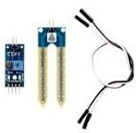

Figure 7: Soil Moisture Sensor

ESP 32
Is a series of low-cost, low-power system on a chip mi- crocontrollers with integrated Wi-Fi and dual-mode Blue- tooth. The ESP32 series employs either a Tensilica Xtensa LX6 microprocessor in both dual-core and single-core variations, Xtensa LX7 dual-core microprocessor or a single- core RISCV microprocessor and includes built-in antenna switches, RF balun, power amplifier, low-noise receive amplifier, filters, and power-management modules. ESP32 is created and developed by Espressif Systems, a Chinese com- pany based in Shanghai, and is manufactured by TSMC using their 40 nm process. It is a successor to the ESP8266 micro controller.
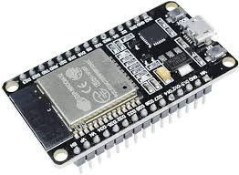

Figure 8: ESP 32

MQ-4 Gas Sensor
The MQ-4 Gas Sensor is a popular semiconductor gas sensor used to detect the presence of methane (CH4) and other flammable gases in the air.The MQ-4 sensor operates on the principle of changes in resistance when it comes into contact with the target gas. As the concentration of the gas increases, the sensor’s resistance decreases.
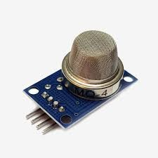

Figure 9: MQ-4 Gas Sensor

Motor Driver - L298N
The L298N is a dual H-bridge motor driver integrated circuit (IC) commonly used to control and drive DC motors, particularly in robotics and mechanics applications. It provides a straightforward way to manage motor direction and speed using control signals from micro-controllers like Arduino. The L298N motor driver has a supply range of 5v to 35v and is capable of 2A continuous current per channel, so it works well with most of the DC motors. The L298N is valued for its efficiency, ease of use, and versatility, making it a popular choice for hobbyists and engineers working on projects involving motor control.
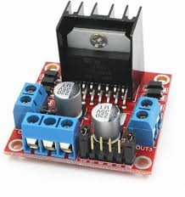

Figure 10: Motor Driver - L298N

Wheels
Wheels with good grip are used so that the bot moves freely through the pipes.They reduce friction, making it easier to transport heavy loads and navigate obstacles. We can traverse through rough terrain as they have good grip. The ones we are using are made of plastic and rubber.

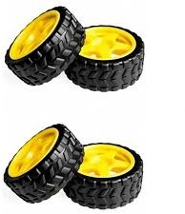

Figure 11: Wheels
  - Software

Fusion 360
Fusion 360 is a computer-aided designing (CAD) software application for 3-D modelling and simulation. It’s other functions include computer-aided manufacturing (CAM) and computer-aided engineering (CAE), as well as designing printed circuit boards. Fusion 360 provides powerful 3D modeling tools that allow users to create complex 3D models of products and components.

IR Sensor
An infrared sensor is a radiation-sensitive optoelectronic component with a spectral sensitivity in the infrared wave- length range 780 nm . . . 50 µm. IR sensor used in motion detectors, which are used in building services to switch on lamps or in alarm systems to detect unwelcome guests.An IR (infrared) sensor is a type of photo detector that detects infrared radiation emitted by an object or surface within its field of view.

Fritzing



Figure 14: Fusion 360

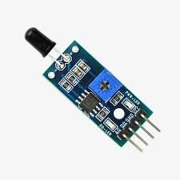

Figure 12: IR Sensor

2.13 Arduino UNO
Arduino UNO is a low-cost, flexible, and easy-to-use programmable open-source micro controller board that can be integrated into a variety of electronic projects. This board can be interfaced with other Arduino boards, Arduino shields, Raspberry Pi boards and can control relays, LED, servos, and motors as an output.

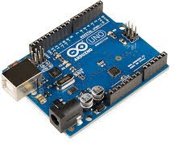

Figure 13: Ardiuno UNO
Fritzing is an open-source electronic design automation
(EDA) software to design electronics hardware, printed circuit boards and schematic circuit diagrams. It is an offshoot of the Processing programming language and the Arduino micro controller.Fritzing allows users to create electronic circuits by dragging and dropping various components (e.g., resistors, LED, micro controllers) onto a virtual breadboard. Users can connect components by drawing wires to represent electrical connections.
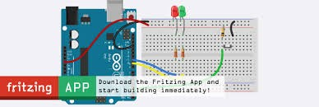

Figure 15: Fritzing

Blynk IOT
Blynk is an IOT platform for iOS or Android smartphones that is used to control micro-controllers.This application is used to create a graphical interface or human machine interface (HMI) by compiling and providing the appropriate address. Blynk offers a mobile app for Android and iOS devices that allows users to design and control their IoT projects through phone or a tablet.



Figure 14: Blynk IOT

2.2.4 Arduino IDE
You can compile your code within the IDE to check for errors and then upload the compiled program (known as a sketch) to the connected Arduino board. The IDE handles the compilation and uploading process seamlessly.


Figure 17: Arduino IDE

Implementation and working:

Circuit diagram

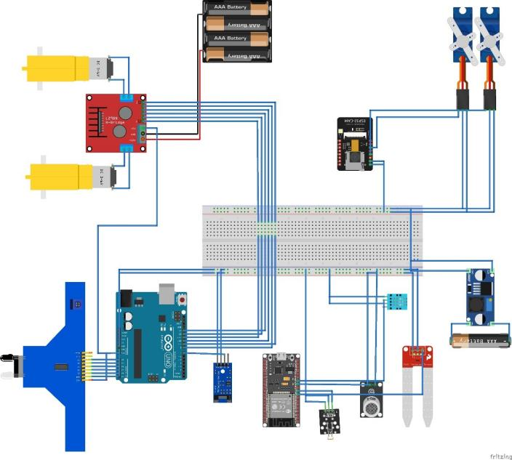
Figure 18: circuit diagram

Figure 19: Block diagram

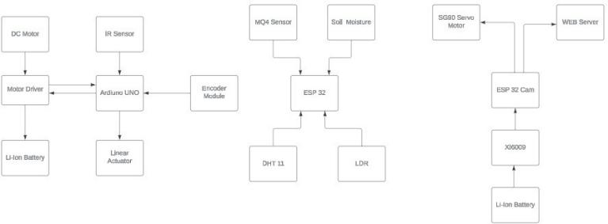
Block diagram
  - Working Mechanism
The smart agriculture bot is a line following bot with vari- ous types of sensors such as moisture,gas,soil,IR etc. In this bot we will be using a Arduino board,this bot helps to get to know the moisture of the soil with moisture sensor,the gas sensor detects whether the fruit is ripe,not ripe or over- ripe, the line following bot identifies the obstacle the linear actuator moves up and down the soil with the moisture sensor.MQ4 is the moisture sensor.The bot follows and identifies the black objects by using a IR sensor.The smart agriculture bot helps to reduce the human work.It can replace a number of humans working in the particular field.

Experimental Results and Conclusions:

Results
The smart agriculture line following bot reduces the human usage in different fields.This bot helps the human in many ways it can give the moisture,humidity of the soil at a particular area of land.ESP 32 cam gives the 180 degrees of the plant. By using the Blynk app we will be able to get the information of the plant in our phone.At last the line fol- lowing bot can follow and detect the black coloured objects in its way.

Future Enhancements
Enhancing a smart agriculture line-following bot involves integrating advanced technologies and improving its existing functionalities to increase efficiency, adaptability, and productivity. Here are some potential future enhancements. AI and Machine Learning Integration:* - *Adaptive Learning:* Implement machine learning algorithms to allow the bot to adapt to different environments and crop types, optimizing its path and tasks based on real-time data. - *Predictive Analytics:* Use AI to predict crop health issues, soil conditions, and weather impacts, enabling proactive measures.

Conclusion
In conclusion, the future of smart agriculture line-following bots holds tremendous potential to revolutionize modern farming practices. By integrating advanced technologies such as AI, machine learning, multi-spectral imaging, and IOT connectivity, these bots can significantly enhance precision, efficiency, and sustainability in agriculture. Future enhancements focusing on adaptive learning, autonomous navigation, all-terrain capabilities, and collaborative robotics will further empower farmers to optimize crop management, reduce resource usage, and increase productivity. As these innovations continue to evolve, smart agriculture line following bots will play a pivotal role in addressing the global challenges of food security, environmental sustainability, and agricultural efficiency, ushering in a new era of intelligent farming.

References
- International Research journal of Engineering and technology(IRJET),Robot to The Smart Agriculture Line Fol- lowing Bot.
- IEEE Papers The Smart Agriculture Line Following Bot.
pinMode(IR3,INPUT); pinMode(IR4,INPUT); pinMode(IR5,INPUT); pinMode(IN1,OUTPUT); pinMode(IN2,OUTPUT); pinMode(IN3,OUTPUT); pinMode(IN3,OUTPUT); pinMode(IN4,OUTPUT); pinMode(ENA,OUTPUT); pinMode(ENB,OUTPUT);
}
void loop() {
int ir1_val=analogRead(IR1); int ir2_val=analogRead(IR2); int ir3_val=analogRead(IR3); int ir4_val=analogRead(IR4); int ir5_val=analogRead(IR5); if(ir3_val)
forward();
else if(ir1_val||ir2_val) f_left();
else if(ir4_val||ir5_val) f_right();
else stopmo();

CAD
}
void stopmo()
{

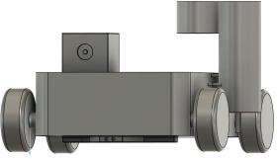
analogWrite(ENA,255); digitalWrite(IN1,LOW); digitalWrite(IN2,LOW); analogWrite(ENB,0); digitalWrite(IN3,LOW); digitalWrite(IN4,LOW);
}

Figure 20: CAD Design Of The Prototype

Source Code
#define ENA 11
#define ENB 9
#define IN1 12
#define IN2 13
#define IN3 10
#define IN4 8 #define IR1 A0 #define IR2 A1 #define IR3 A2 #define IR4 A3 #define IR5 A4 void setup() {
// put your setup code here, to run once: Serial.begin(9600);
pinMode(IR1,INPUT); pinMode(IR2,INPUT);
void forward()
{
analogWrite(ENA,255); digitalWrite(IN1,HIGH); digitalWrite(IN2,LOW); analogWrite(ENB,255); digitalWrite(IN3,HIGH); digitalWrite(IN4,LOW);
}
void backward()
{
analogWrite(ENA,255); digitalWrite(IN1,LOW); digitalWrite(IN2,HIGH); analogWrite(ENB,255); digitalWrite(IN3,LOW); digitalWrite(IN4,HIGH);
}
void f_right()
{
analogWrite(ENA,0); digitalWrite(IN1,LOW); digitalWrite(IN2,LOW);

analogWrite(ENB,255); digitalWrite(IN3,HIGH); digitalWrite(IN4,LOW);
}
void f_left()
{
analogWrite(ENA,255); digitalWrite(IN1,HIGH); digitalWrite(IN2,LOW); analogWrite(ENB,0); digitalWrite(IN3,LOW); digitalWrite(IN4,LOW);
}
void b_right()
{
analogWrite(ENA,0); digitalWrite(IN1,LOW); digitalWrite(IN2,LOW); analogWrite(ENB,255); digitalWrite(IN3,LOW); digitalWrite(IN4,HIGH);
}
void b_left()
{
analogWrite(ENA,255); digitalWrite(IN1,LOW); digitalWrite(IN2,HIGH); analogWrite(ENB,0); digitalWrite(IN3,LOW); digitalWrite(IN4,LOW);
}
}

List of Expenses

ESP 32 | 370
ESP 32 Cam | 550
Cable | 50
Arudino UNO | 480
MQ4 | 120
DHT 11 | 85
IR Sensor | 171
Bread Board | 50
Jumper Wires | 60
L298N | 125
18650 Battery | 330
Holder and Battery | 100
Pan Tilt Servo | 120
SG90(3) | 330
Soil Moisture | 50
Tyres | 100
LDR | 70
Buck Booster XI 6009 | 100
Encoder Module | 50
TOTAL AMOUNT | 3,333

